THE CURIOUS CASE OF TIME TABLE

-MEHAR JOSSAN, GTBIT

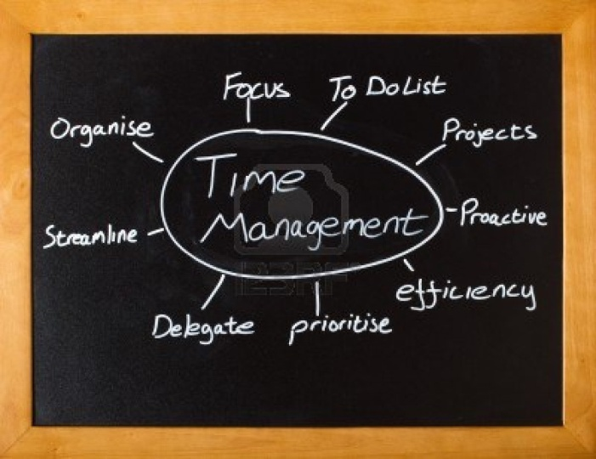

Time Table

11:00-12:00-Maths

12:00-2:00-Science

2:00-3:00-English

and the list goes on.

Umm...Yes, this is my timetable for the day. I resolve to follow it word for word. These are my thoughts at the start of the day and as the day drags I do my ritual breaking of the time table, in a failed attempt to manage time. Yes, time management does get many of your things straight, giving you ample time for work, play and to do things of your own.

Management means anything that reduces the work load pressure or puts it in a more systematic manner. But yeah, this is not desirable for people like me, who prefer postponing. But the multifold advantages of time management cannot be ignored. Productivity is the key point. Loitering here and there over haphazard planning gets you nowhere, whereas systematic time management with utmost concentration yields great productivity. Those 10 hours of work, if done following a lucid plan can be wrapped up in almost half the time. Managing time well leaves ample time for you to relax. Rather relaxation sans guilt. Not saying that I don’t relax with work lurking over my head. But my conscience shouts at me, “You are a stubborn flab of skin. Get to work”. No doubt I lower down the volume of this blaring voice to nearly mute but her presence doesn’t let me relax on my own accord. By going on the lines of time management, it doesn’t necessarily refer to you being stubborn and being called ‘Mr. Grumpy’.

Flexibility is another name of life. But when needed you should be able to manage work load in the given time constraints. One way to realize this is to set up very realistic goals in your attempt to manage time. Setting up of sky rocketing goals will make you end up in muddle and you might feel dejected and get over the idea of ‘time management’. One hurdle towards effective time management that I usually face is ‘day dreaming’. “Water can be seen in three forms namely: solid as ice, liquid…”before the teacher can finish her line I am far transported to the far world. I am skiing in the dense ice, going over bend and sharp turns when suddenly I take a bad jolt and come to halt and am woken from my day dream.

Admit it or deny it, time management is advantageous and is crucial for everyone to succeed. Meanwhile, after writing this, I again resolve to make a fresh time table for tomorrow in an attempt to stick to it at least this time.

(Icon)

